**Instant Data Analysis in Advanced Excel**

Instant data analysis is a feature of advanced excel. Users can **easily analyze and visualize data** from many sources in a **single worksheet**thanks to this feature of Excel. Users can **connect to data sources, leverage strong analytics, and get insights immediately.** Users of this feature can make data-driven choices, easily spot patterns and outliners, and display data using graphs and charts. The following is the **list of Instant data analysis tools** provided by advanced excel.

1. **Formatting:**By including elements like **data bars and colors**, formatting enables you to emphasize **specific portions of your data.** This, among other things, enables you to **readily see high and low quantities.**
2. **Charts:**Data is**visually represented using charts.** To fit various sorts of data, there are several chart types.
3. **Totals:**It is used to perform **different types of calculations** of the**values stored in columns and rows**. Like Sum, Count, Average, and others.
4. **Tables:**You can **filter, sort, and summarize your data using tables.** Forex: Table and Pivot Table.
5. **Sparklines:**Sparklines, you can display **alongside your data in the cells**, which resemble **little charts.** They give easy access to the trends of the data.

**Steps to Apply Instant Data Analysis**

**Step 1: Select**the **cells containing the data** that you wish to analyze. Now **a button will appear on the bottom right** of the selected data called the **Quick Analysis Button**.

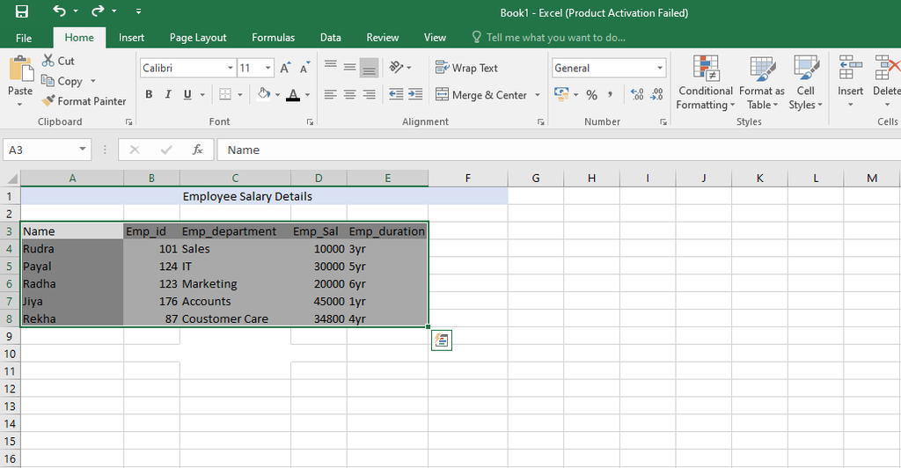

**Step 2:**Click onthe **Quick Analysis Button,** now you will see Formatting, Charts, Totals, Tables, and Sparklines toolbar choices available in the**Quick Analysis Button.**

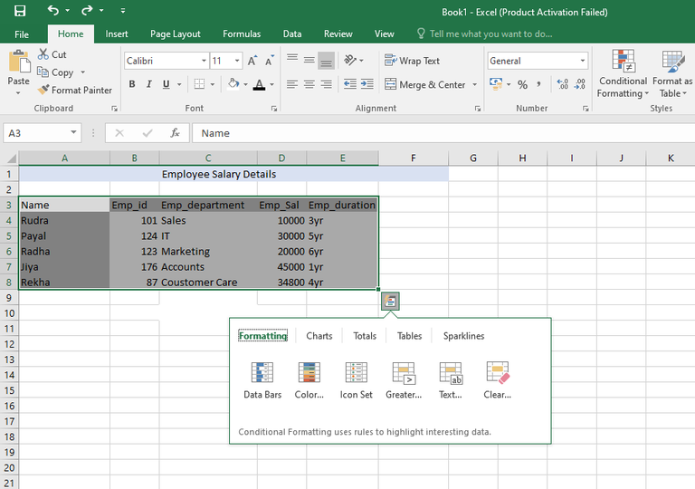

**Steps to Apply Formatting**

The rules are used by **conditional formatting to emphasize the data**. Although this option is also on the**home tab** at the top of the ribbon, it may be used**quickly and conveniently with a little bit of investigation**. Additionally, you may apply many settings to get a preview of the data before choosing the one you want. There are many types of formatting, For example, Data Bars, Icon Sets, Color Scale, Greater Than, Top 10%, and Clear Formatting.

**Step 1: Click on the Formatting button**and then click on **Data Bars.**

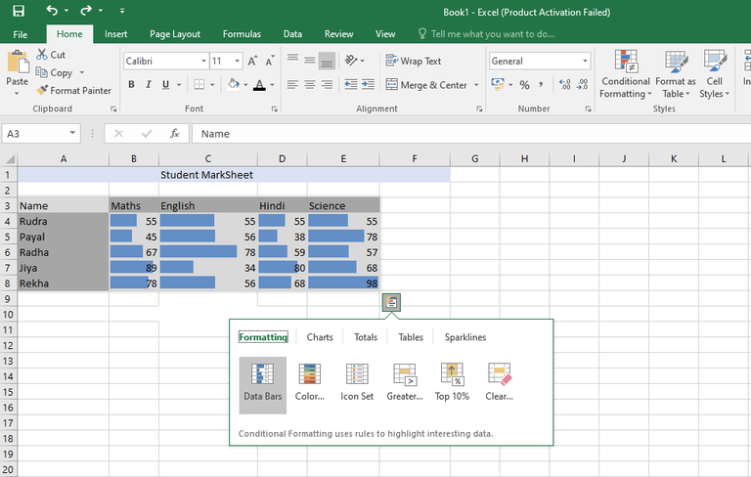

The colored data bars that correspond to the data’s value are displayed.

**Step 2:**Clickon **Color Scale.**

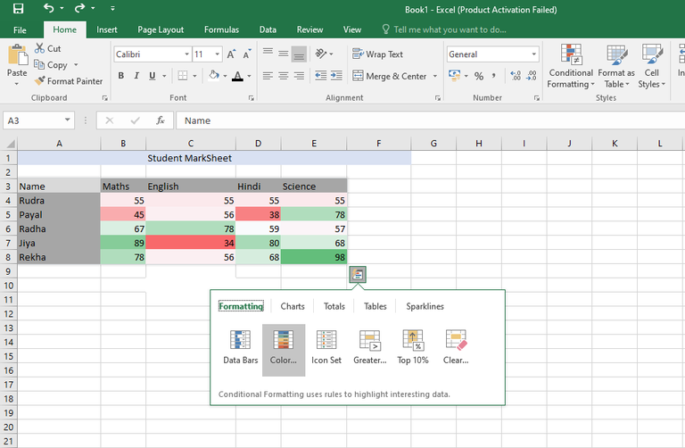

According to the data they hold, the cells will be colored according to their respective values.

**Step 3:**Click on **Icon Set.**

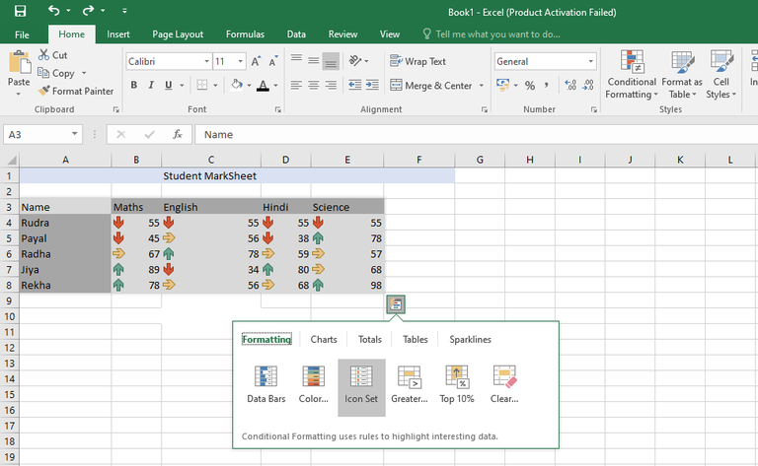

The cell value-associated icons will be displayed.

**Step 4:**Click on **Greater than.**

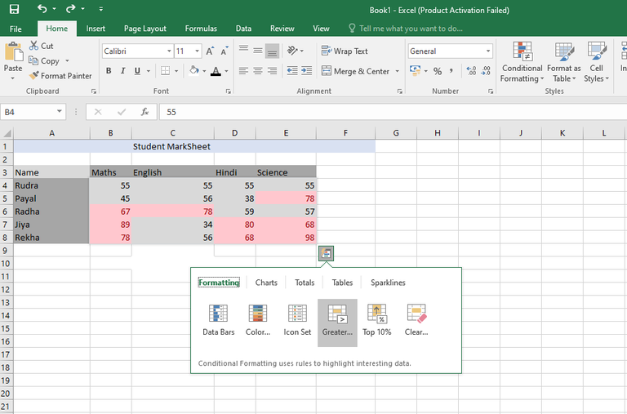

A **dialog box will appear** whenyou click on Greater than, there you can enter your own value.

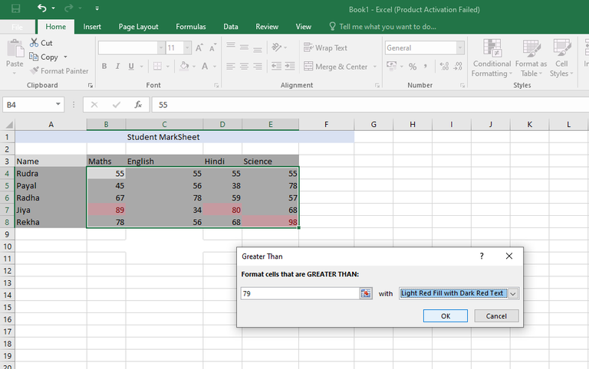

**Step 5:**Click on **Top 10%.**

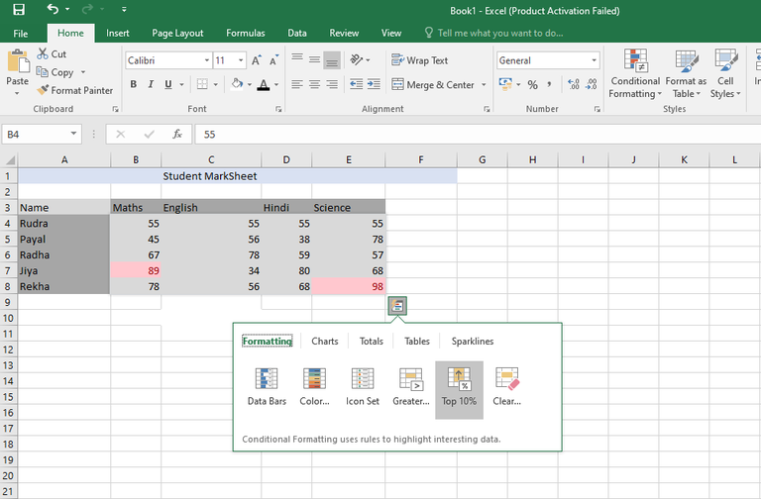

The top 10% of values will be highlighted with color.

**Step 6:**Click on **Clear Formatting.**

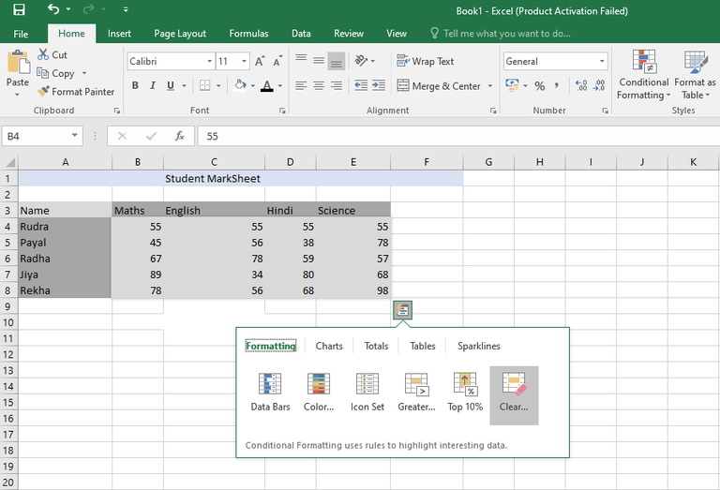

It will clear all the applied formatting. That’s all about Formatting, now let’s see how to apply Charts.

**Steps to Apply Charts**

Charts make it easier to **visualize your Data stored**in an Excel worksheet.

**Step 1:**Click on**Charts.** You can see different kinds of charts available.

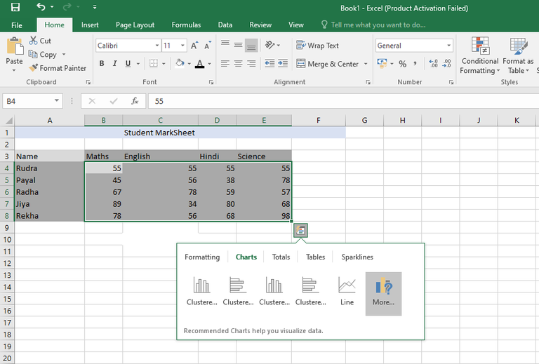

You can**hover over all types of charts**, see**how data is displayed in each chart,** and **choose one** according to you.

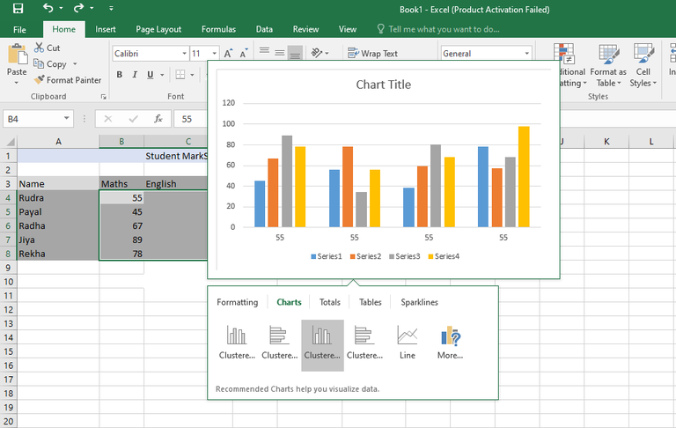

Click on **more**to see **more available charts.**

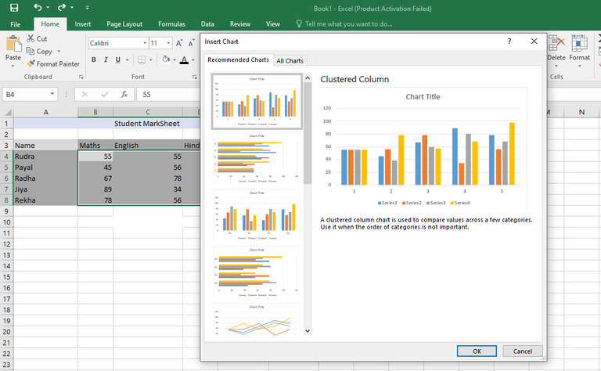

That’s all about Charts. Let’s see how to apply Totals.

**Steps to Apply Totals**

It is used to perform different types of **calculations of the values stored in columns and rows.** Like Sum, Count, Average, and others.

**Step 1:**Click on **Totals**. You can see different functionality offered by Totals displayed. You can see more functionality offered by Totals by clicking the right arrow key.

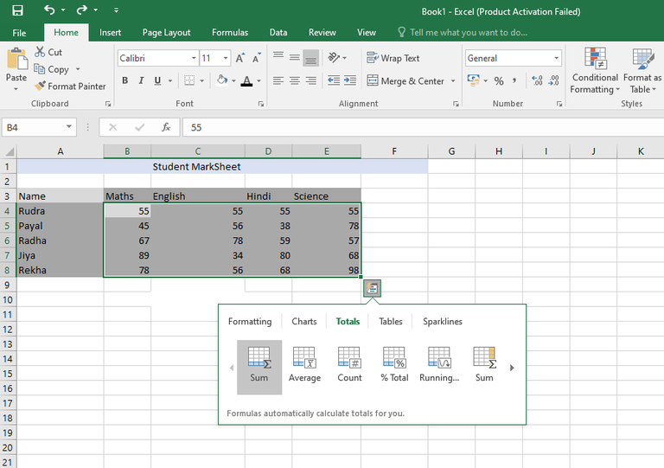

**Step 2:**Click on**Sum.**This will give the **total sum of all the numbers stored in a column.**

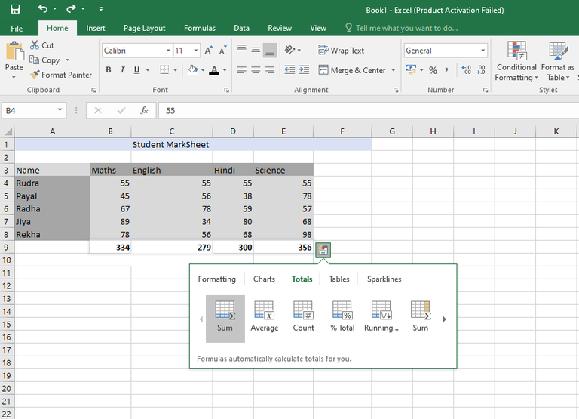

The numbers in the columns are added using this option. Similarly, there is an option to **find the total sum of all the numbers stored in the row.**

**Step 3:**Click on **Average.** The **average of the values in the columns** is determined**using this parameter.**

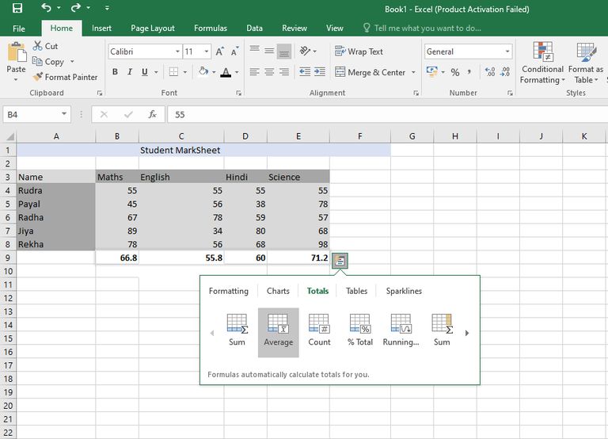

Now it will show the average of all the subjects.

**Step 4:**Click on **Count**. The **number of values present in the columns**is determined using this**parameter.**

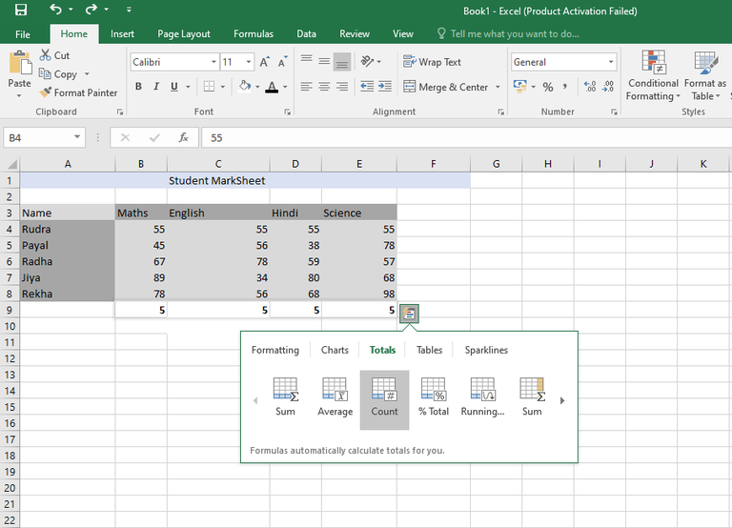

Now, it will show the count of all the subjects.

**Step 5:**Click on **%Total.** This option **calculates the percentage of the column** that corresponds to the **entire sum of the specified data values.**

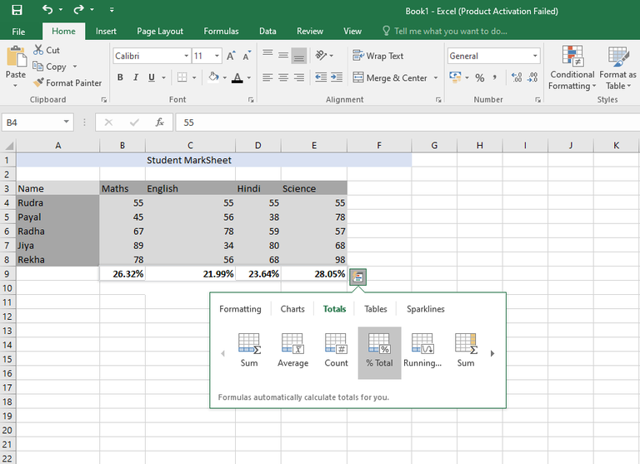

Now, it will show the %Total of all the subjects.

**Step 6:**Click on **Running Total.** This shows each column’s running total.

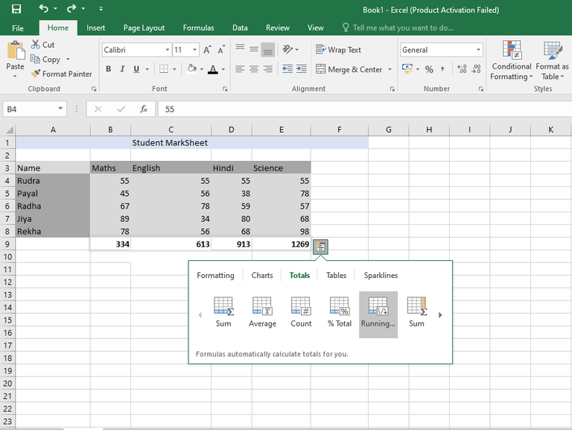

Now, it will show the running column of all the subjects. That’s all about Totals. Let’s see how to apply Tables.

**Steps to Apply Tables**

You can**filter, sort, and summarize your data using tables.**

**Step 1:**Click on**Tables.** You will see **different options inside “Tables”.**

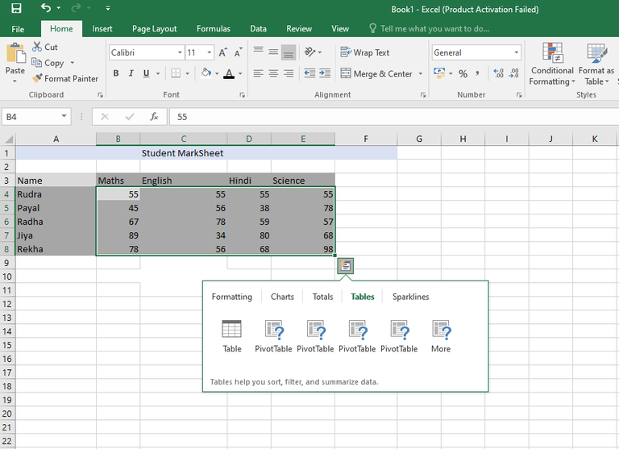

You can hover over each option and see their preview and then choose the one according to you.

**Step 2:** Click on **Table**.

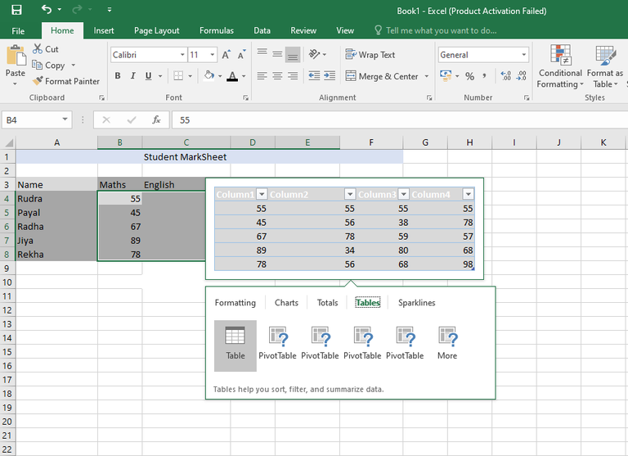

Using the table, you can sort and filter the data.

**Step 3:**Click on **Pivot Table.**Pivot tables assist you to condense your data.

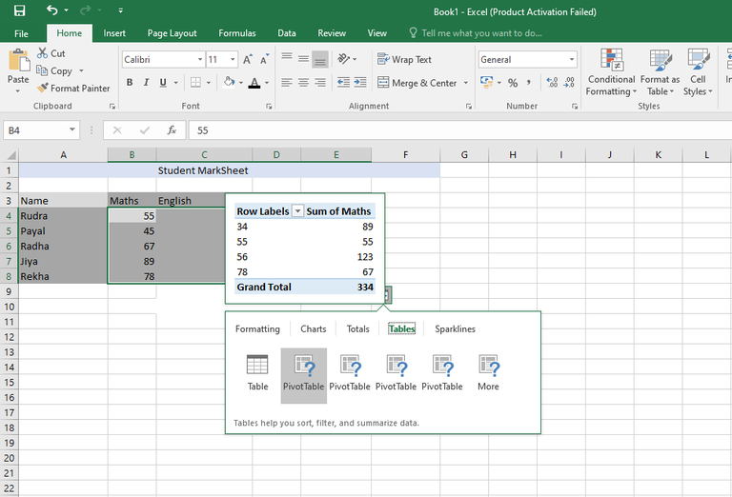

That’s all about Tables. Let’s see how to apply Sparklines.

**Steps to Apply Sparklines**

Sparklines, you can**display alongside your data in the cells,** which **resemble little charts.** They give easy access to the trends of the data.

**Step 1:**Clickon **Sparklines.**

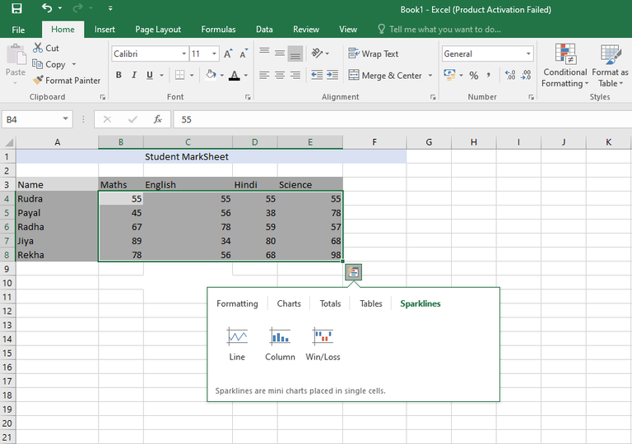

**Step 2:**Choose Line.

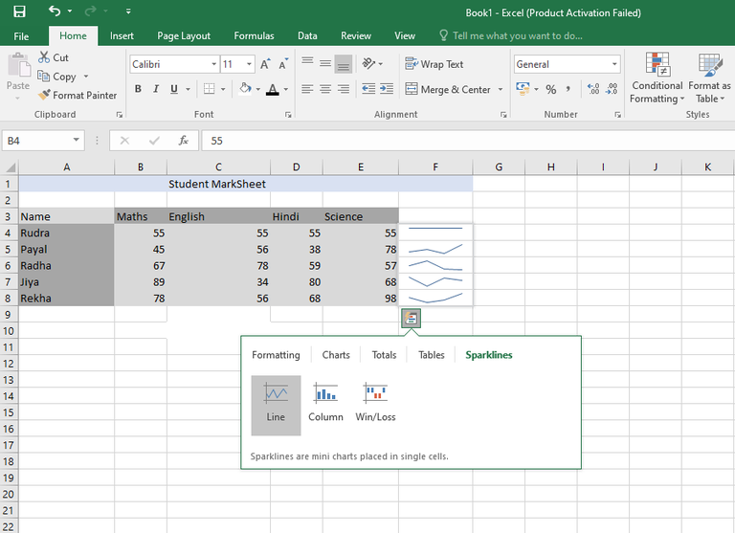

For each row, a line chart is displayed.

**Step 3:**Choose Column.

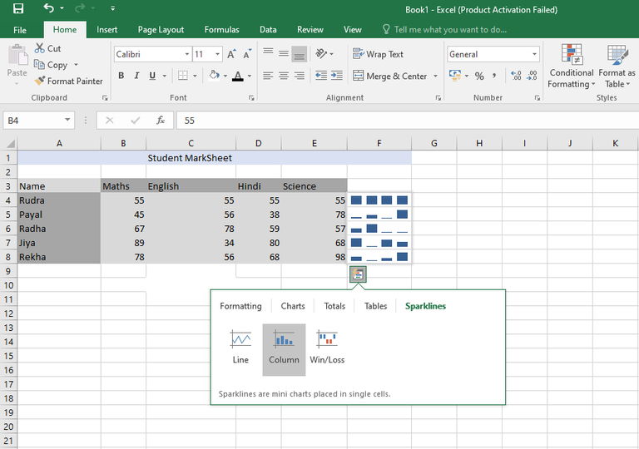

For each row, a column is displayed.

**Step 4:**Choose Win/Loss.

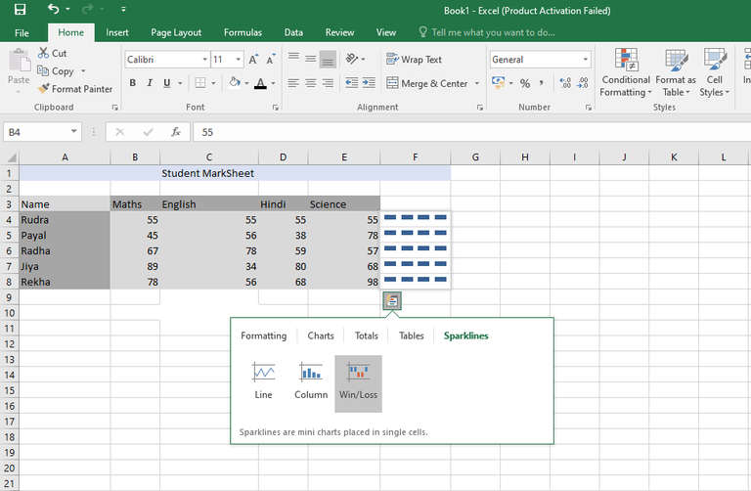

 For each row, a win/loss is displayed.